**STOOPID AAH ERROR THAT I HATE**

And how to fix it ! (With pictures)

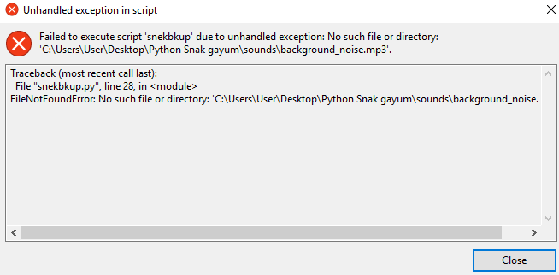

Step 1. Go to Disk C:

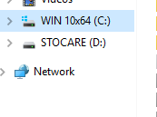

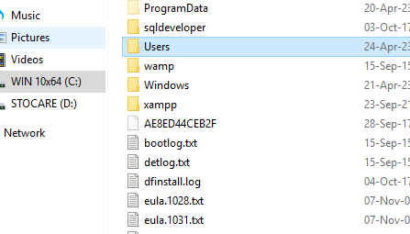Step 2. Go to “Users”

Step 3. Go to “User”

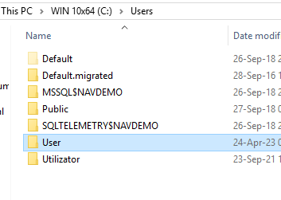

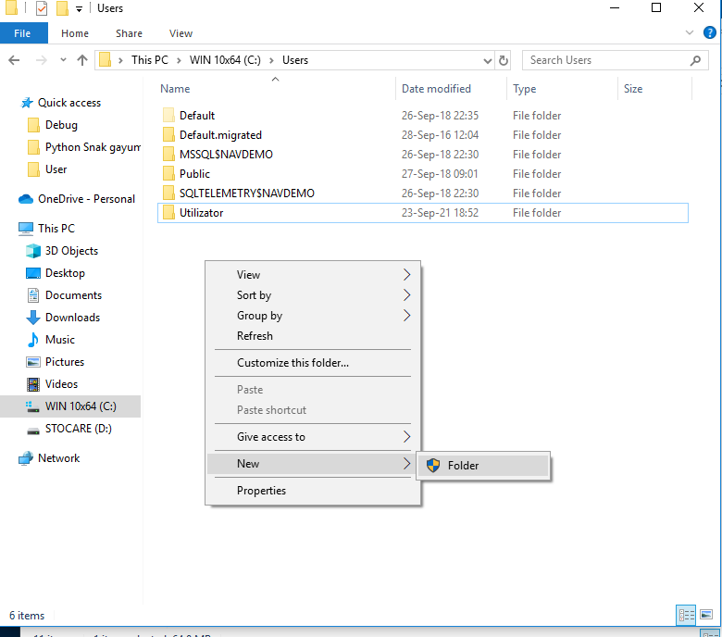Step 3.5. No “User” folder? No problem! Just make one!

Step 4. Go to the “Desktop” folder

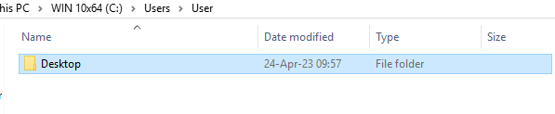

Step 4.5 No “Desktop” folder? No problem! Just make one

Step 5. Make a new folder with the name “Python Snak gayum”

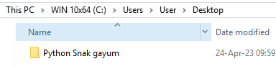

Step 6. The “Python Snak gayum” folder **MUST** have these 2 files !

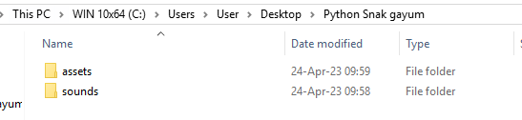

How do you get those files?

**EASY!!!**

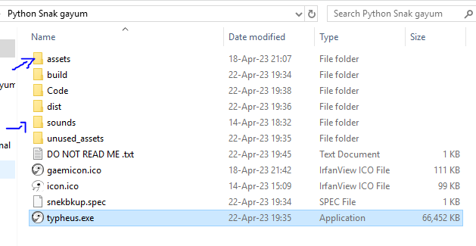Step 7. Go to the ACTUAL game folder !!! (The one with the .exe)

AND COPY THE “assets” and “sounds” FOLDERS IN HERE !!



MAKE SURE THAT THE FOLDERS HAVE FILES IN THEM !!!!!

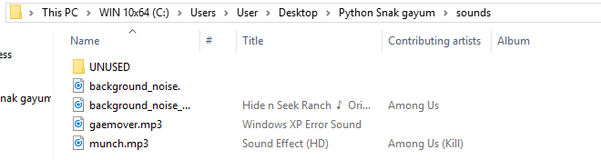**EXAMPLE HERE vvvv**